

**STANDARD OPERATING PROCEDURE**

**Do not Photocopy**

**Document Information Classification: Unrestricted**

|  |  |
| --- | --- |
| **Title:** | **Induction of new staff and students** |
| **Effective Date:** | **09 May 2019** |
| **Reference Number:** | **SOP-01-01** |
| **Version Number:** | **2.8** |
| **Owner:** | **Staff Management Process Owner,** |
| **Review Date:** | **13 Nov 2021** |

Table of Contents

1. Purpose 3

2. Scope 3

3. Responsibilities 3

4. Procedure 4

4.1. Actions before the arrival of a member of staff 4

4.2. CHI Induction 4

4.3. Induction support and further training 4

5. Cross-referenced ISMS Documents 4

6. Appendices 5

6.1. Guidelines for Adding FORM-004 to Q-Pulse Person Record 5

1. Purpose

All employees of the organization should be identified and a person record should be created and maintained. The employees should also receive appropriate awareness education and training as relevant for their job function.

This document describes the procedure for the induction of new starters in CHI and the creation of the Q-Pulse person record.

1. Scope

This SOP describes the procedure for the induction of new CHI staff and students. It also applies to non-CHI staff and students working on the TRE or resident in Vaughan House and existing members of the University who begin working at CHI.

Note: For simplicity this in-scope group shall be referred to throughout the remainder of this procedure as ‘new CHI staff’ unless a specific distinction is necessary.

It includes for the activities to introduce new CHI staff to the CHI organization and the ISMS and ensure they are set up on the ISMS and other CHI systems as necessary for their role.

University and faculty induction activities are out of scope of this procedure although new CHI staff must also complete the university and faculty induction including welcome events, checklists and mandatory training.

1. Responsibilities

The relevant Line Manager is responsible for:

* Advising CHI Staff Administration of any new CHI staff
* Notifying the Q-Pulse Administrator of their details
* Ensuring a CHI induction is scheduled and completed in a timely manner
* Working with the new starter to identify any requirement for additional training
* Uploading the completed FORM-004 checklist to Q-Pulse

CHI Staff Administration is responsible for:

* Arranging the provision of the necessary IT equipment for new starters

The Q-Pulse Administrator is responsible for:

* Creating a user account on Q-Pulse for any new CHI staff
* Ensuring the new starter is assigned to the correct ISMS documents in scope for their role

The new member of CHI staff is responsible for:

* Completion of relevant CHI induction activities
* Raising requests for additional training as necessary

Where the in scope person is line managed by a person that is outside of CHI then a CHI ”surrogate” line manager will be assigned who will complete the designated ISMS line management responsibilities.

1. Procedure
   1. Actions before the arrival of a member of staff
2. The start date of new CHI staff should be communicated by the Line Manager to CHI Staff Administration a minimum of 1 week before their scheduled arrival. This enables the provision of desk space and the setup of the necessary IT equipment.
3. The Line Manager will determine if the new member of CHI staff is in scope of the ISMS. If not, CHI induction is not required.
   1. CHI Induction
4. For new CHI staff the Line Manager will notify the Q-Pulse Administrator with their start date, their full name, email and job title.
5. The Q-Pulse Administrator will generate a user account on Q-Pulse and will email a username and password to the new starter.
6. The Q-Pulse administrator will assign the new starter to the correct ISMS documents in scope for their role and they will receive email reminders to read and acknowledge these documents.
7. The Q-Pulse administrator will also assign the ‘New Starter Induction’ competency to the person record. This will be used to provide reminder prompts to both the new starter and their line manager to complete the induction process.
8. The Line Manager should schedule an induction meeting with the new CHI staff member within a week of their arrival.
9. Induction requirements should include, but are not limited to:
   * Completion of Induction checklist FORM-004. This should be within a month of the start date and uploaded to the new starter’s Q-Pulse record (see Appendix for guideline).
   * Building tour
   * Introduction to information security, policy, objectives and requirements (new starter only)
   * Introduction to Q-Pulse (new starter only)
   * Read and acknowledge relevant ISMS documents in Q-Pulse
   * Acceptable use of CHI’s systems and assets (new starter only)
   * eLab introduction (if required)
   * Signposting to relevant inductions to complete – including resident building
   * Signposting to key individuals to meet
   1. Induction support and further training
10. If required, further support and supervision can be provided until both the Line Manager and the new CHI staff member are confident that they can complete their work to the expected standards.
11. The new staff member can access the University Staff Learning and Development site here: <http://www.staffnet.manchester.ac.uk/staff-learning-and-development/>
12. Cross-referenced ISMS Documents

|  |  |  |
| --- | --- | --- |
| Number | Type | Title |
| FORM-004 | ISMS\Forms | New starter and leaver asset and IT account checklist |
| SOP-01-02 | ISMS\SOP\Personnel & Training - SOP | Managing Training |

1. Appendices
   1. Guidelines for Adding FORM-004 to Q-Pulse Person Record

* Access the person record from the ‘People and TRE User Accounts’ module.
* Click on the menu bar item Actions -> Add Attachment

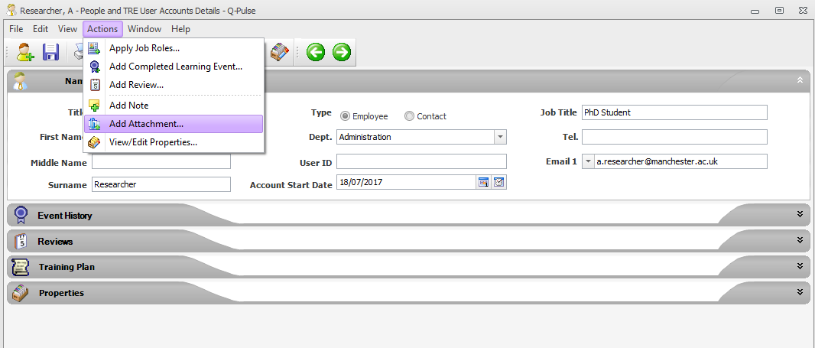

* This displays the ‘Edit Attachment’ dialog.
* Note: this option will not be available if the person record selected is not set within the Q-Pulse reporting structure as being line managed by you.

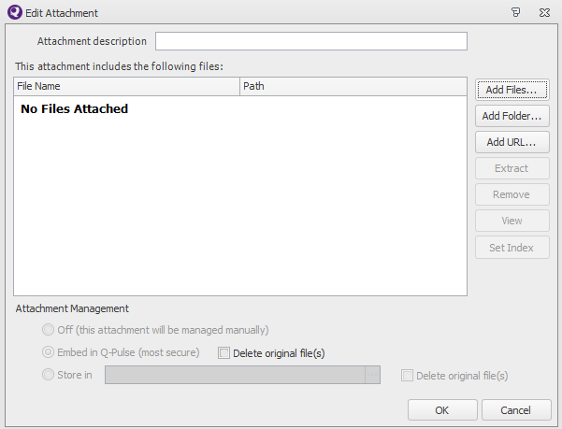

* Click on the  button to display windows explorer where the copy of the completed FORM-004 can be selected.
* Note: the file can be attached as either a Word document (.docx) or a scanned image (.pdf) of the completed form. The file must be closed before it can be attached to Q-Pulse.
* After the file has been selected click on ‘OK’ and save the person record.